ASSIGNMENT NO.11: Indexing and Query Optimization Queries
Student Name | Aditya Ballal | Roll Number | 20966
Batch | SY. BSc Data Science | Topic | WB(Assignment-11)

Questions
Q1) Create a MySQL database named SalesDB and a table named OrderData. OrderData Table
Column Name | Data Type | Constraint
OrderID | INT | PRIMARY KEY
CustomerName | VARCHAR(50) | NOT NULL
Email | VARCHAR(80) | NOT NULL
City | VARCHAR(30) | NOT NULL
ProductCategory | VARCHAR(30) | NOT NULL
OrderDate | DATE | NOT NULL
OrderAmount | DECIMAL(10,2) | NOT NULL
OrderStatus | VARCHAR(20) | NOT NULL

Insert at least 12 records into the table.

Query:

CREATE DATABASE SalesDB;
USE SalesDB;

CREATE TABLE OrderData (
OrderID INT PRIMARY KEY,
CustomerName VARCHAR(50) NOT NULL,
Email VARCHAR(80) NOT NULL,
City VARCHAR(30) NOT NULL,
ProductCategory VARCHAR(30) NOT NULL,
OrderDate DATE NOT NULL,
OrderAmount DECIMAL(10,2) NOT NULL,
OrderStatus VARCHAR(20) NOT NULL
);

INSERT INTO OrderData (OrderID, CustomerName, Email, City, ProductCategory, OrderDate, OrderAmount, OrderStatus) VALUES
(1, 'Rahul Sharma', 'rahul@gmail.com', 'Mumbai', 'Electronics', '2026-01-05', 55000.00, 'Delivered'),
(2, 'Priya Patil', 'priya@gmail.com', 'Pune', 'Furniture', '2026-01-08', 32000.00, 'Delivered'),
(3, 'Aman Verma', 'aman@gmail.com', 'Nashik', 'Clothing', '2026-01-12', 8500.00, 'Pending'),
(4, 'Sneha Joshi', 'sneha@gmail.com', 'Mumbai', 'Electronics', '2026-01-20', 72000.00, 'Delivered'),
(5, 'Karan Mehta', 'karan@gmail.com', 'Thane', 'Furniture', '2026-02-03', 28000.00, 'Cancelled'),
(6, 'Neha Shah', 'neha@gmail.com', 'Pune', 'Electronics', '2026-02-08', 48000.00, 'Delivered'),
(7, 'Rohan Desai', 'rohan@gmail.com', 'Mumbai', 'Clothing', '2026-02-15', 12000.00, 'Pending'),
(8, 'Meera Kulkarni', 'meera@gmail.com', 'Nashik', 'Furniture', '2026-02-22', 36000.00, 'Delivered'),
(9, 'Arjun Nair', 'arjun@gmail.com', 'Thane', 'Electronics', '2026-03-02', 64000.00, 'Shipped'),
(10, 'Divya More', 'divya@gmail.com', 'Mumbai', 'Furniture', '2026-03-07', 41000.00, 'Delivered'),
(11, 'Isha Singh', 'isha@gmail.com', 'Pune', 'Clothing', '2026-03-12', 15000.00, 'Shipped'),
(12, 'Om Jadhav', 'om@gmail.com', 'Mumbai', 'Electronics', '2026-03-18', 59000.00, 'Pending');
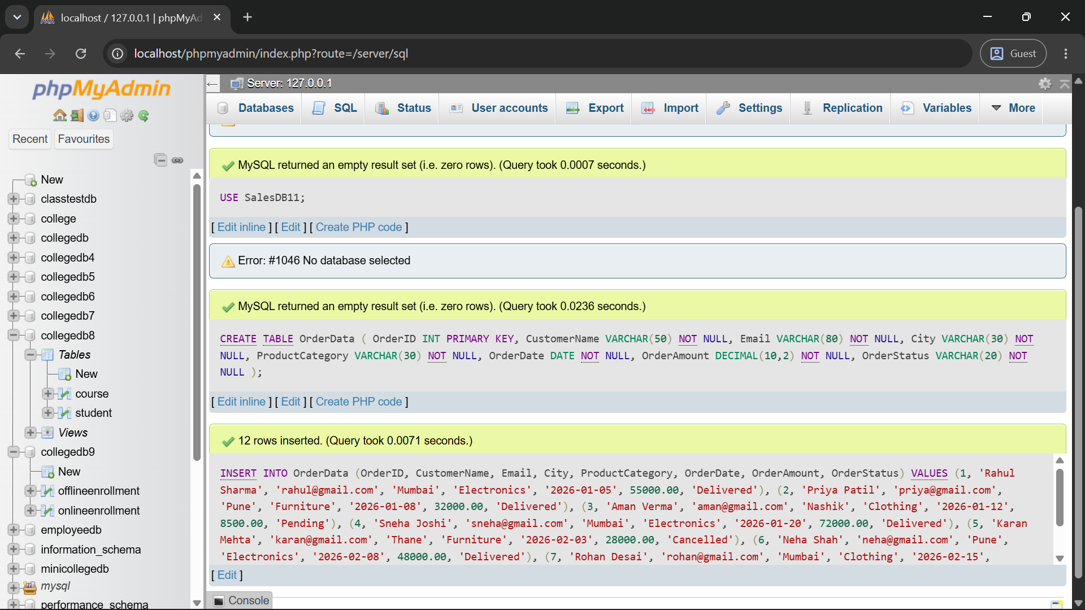

Q2) Create the following MySQL indexes on the OrderData table:
Index Name | Column | Index Type
idx_city | City | Normal index
idx_email | Email | Unique index
idx_order_date | OrderDate | Normal index

Display all indexes using SHOW INDEX.
Query:
CREATE INDEX idx_city ON OrderData(City);
CREATE UNIQUE INDEX idx_email ON OrderData(Email);
CREATE INDEX idx_order_date ON OrderData(OrderDate);

SHOW INDEX FROM OrderData;
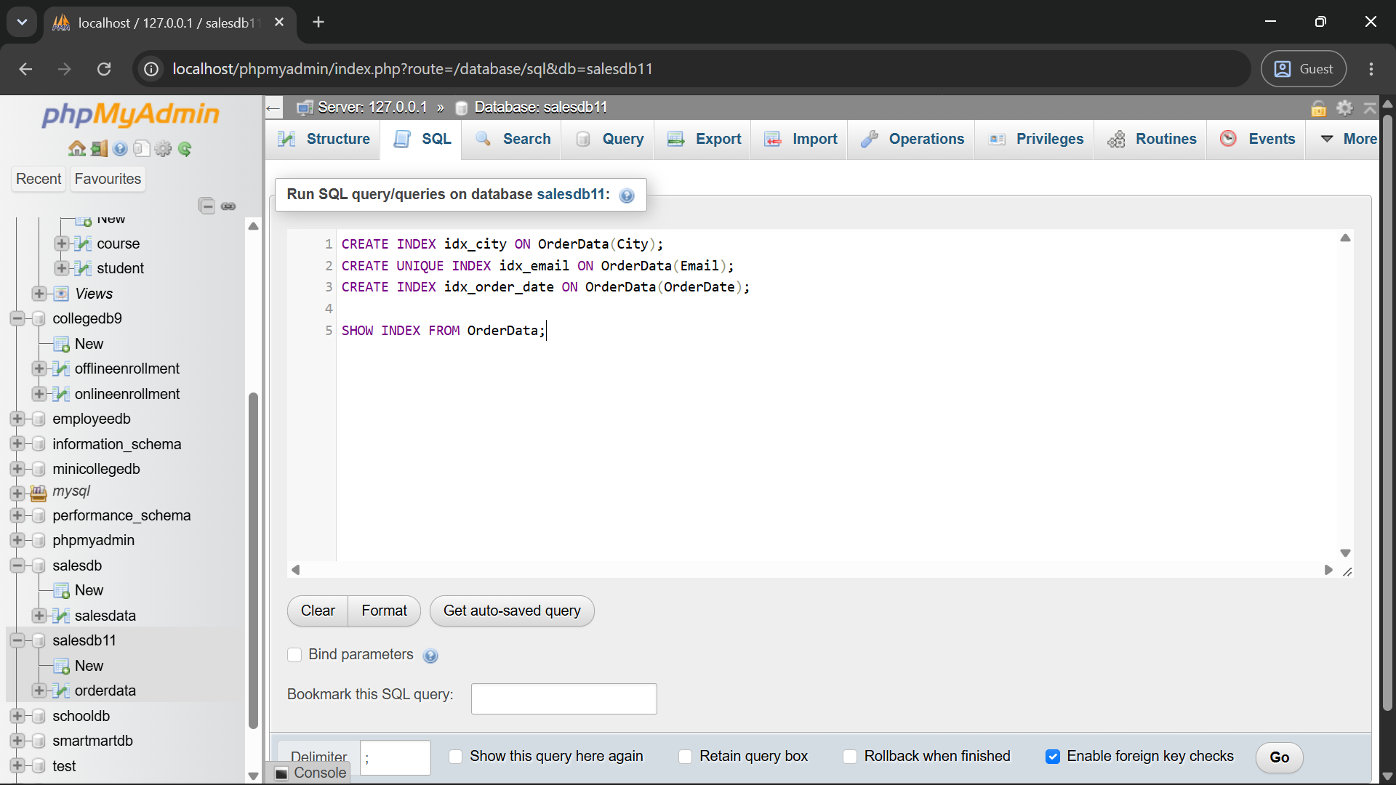
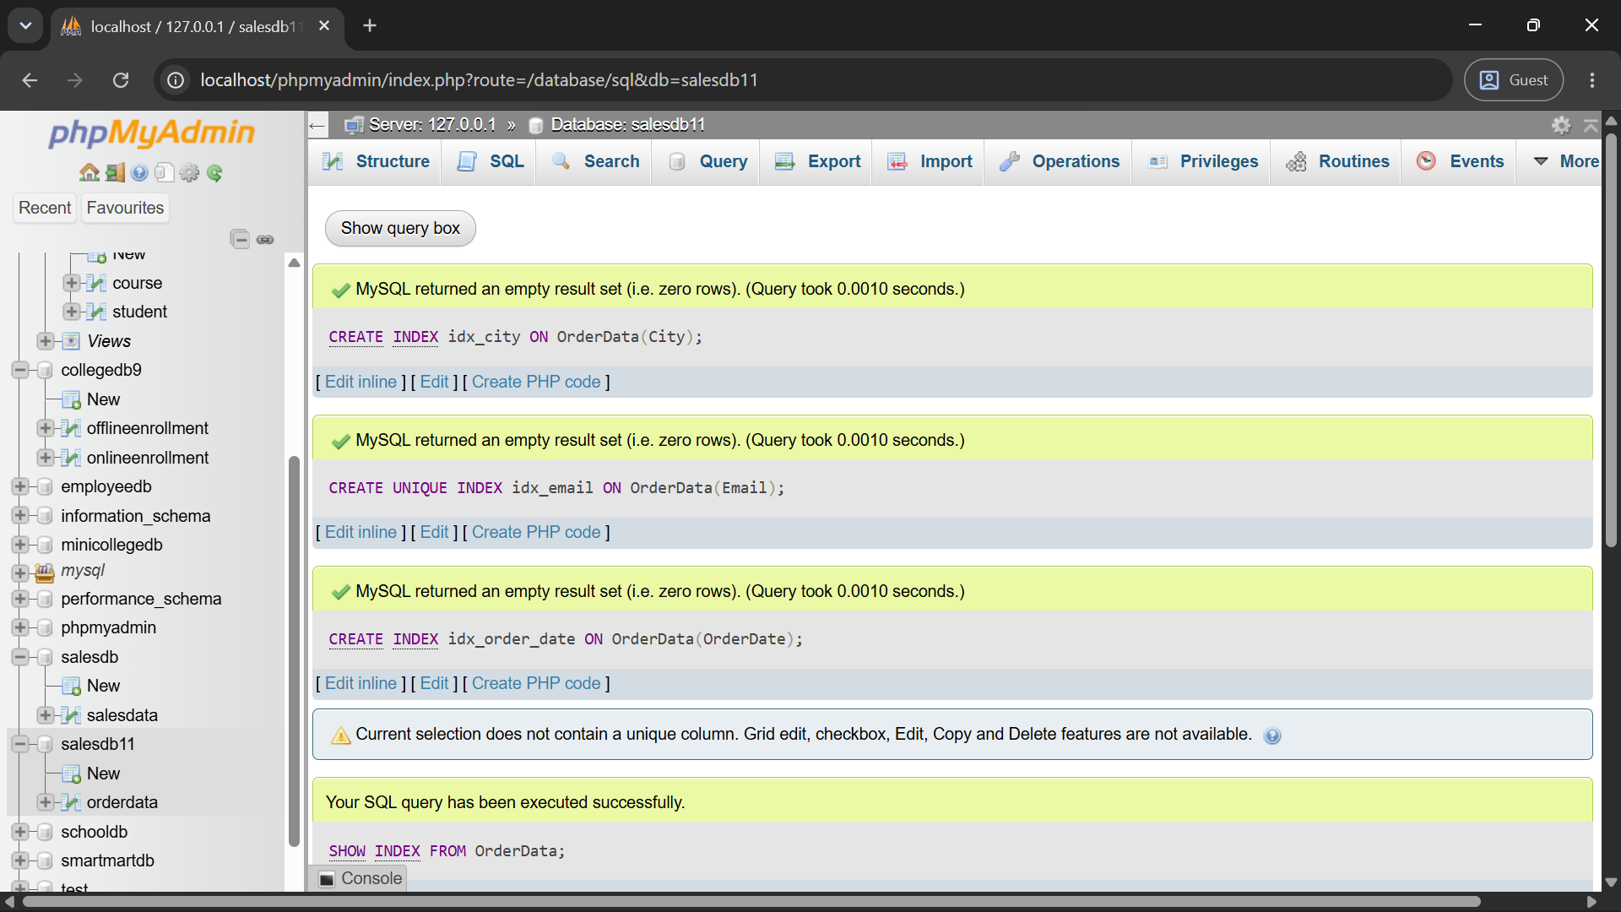
Q3) Create a composite index named idx_city_order_date.
The index should contain:
Index Position | Column
1 | City
2 | OrderDate
Write a query that searches for Mumbai orders within a specified date range.
Query:
CREATE INDEX idx_city_order_date ON OrderData(City, OrderDate);

SELECT * FROM OrderData
WHERE City = 'Mumbai'
AND OrderDate BETWEEN '2026-02-01' AND '2026-03-31';
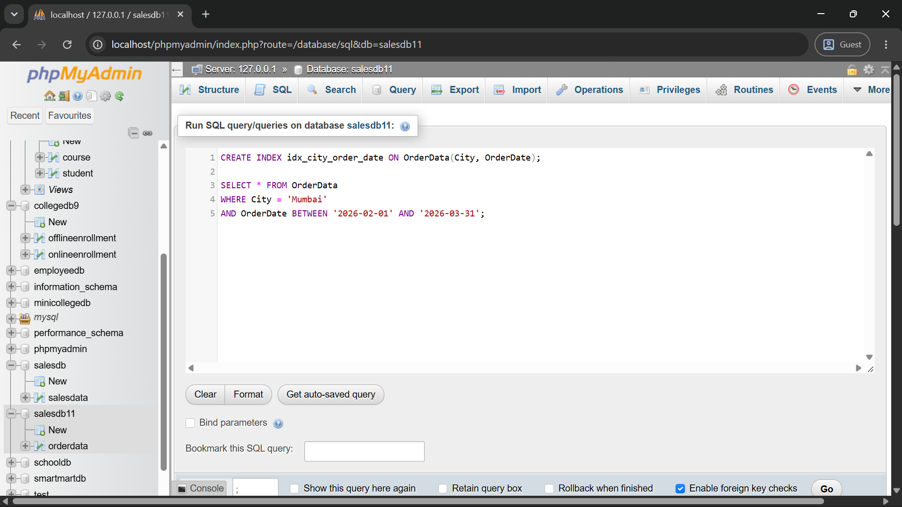
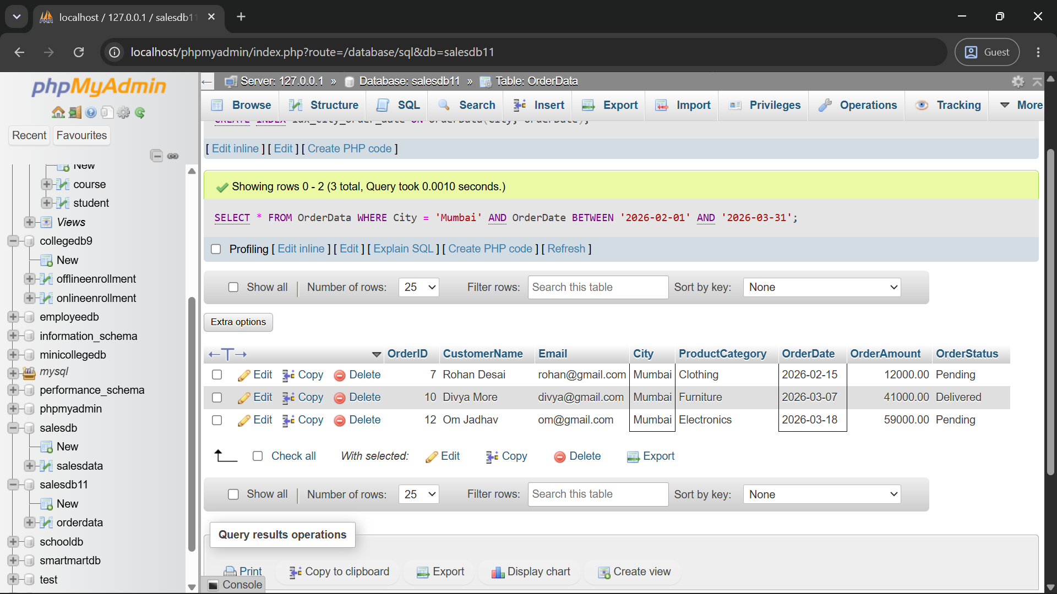
Q4) Write a MySQL EXPLAIN query to analyze the following search:
SELECT *
FROM OrderData
WHERE City = 'Mumbai';
Record and explain the following output columns:
EXPLAIN Column
type
possible_keys
key
rows
Extra
Query:
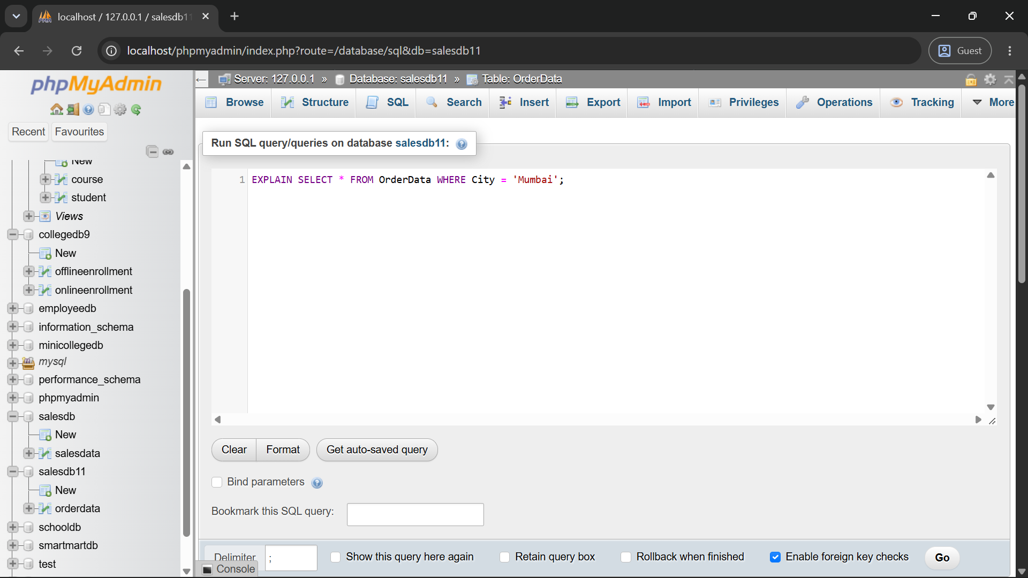
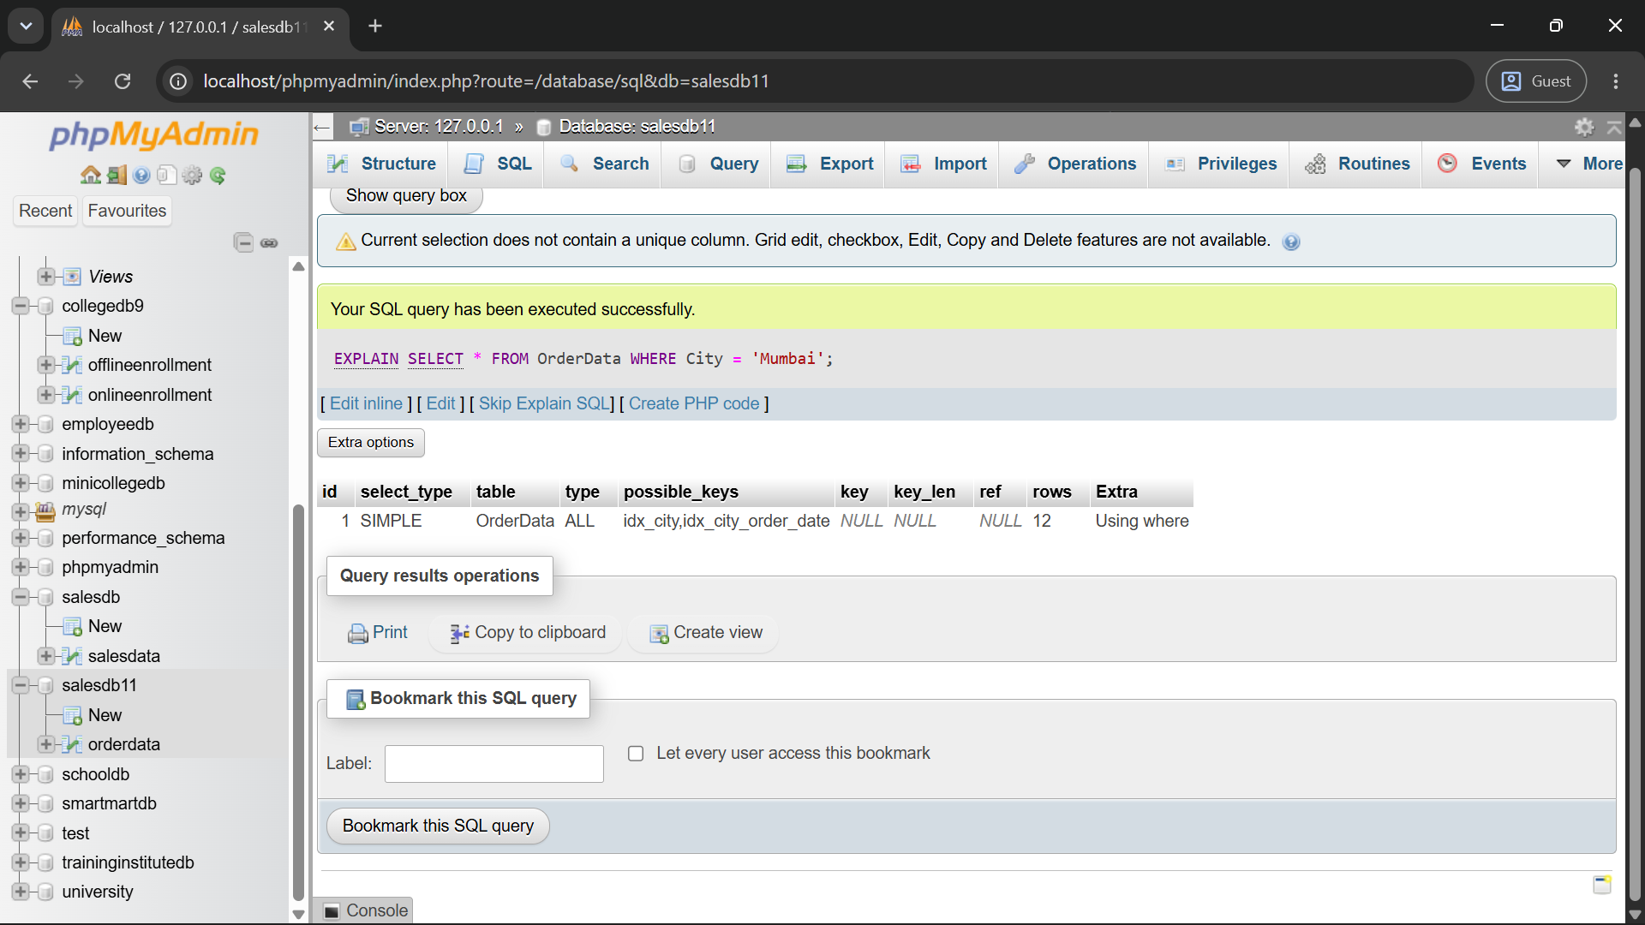
Q5) Compare query performance before and after creating an index on City.
Perform the following steps:
Step | Task
1 | Drop idx_city, if it exists
2 | Run EXPLAIN on the City search
3 | Create idx_city
4 | Run the same EXPLAIN query again
5 | Compare the selected index and estimated rows
Query:
-- Step 1: Drop idx_city, if it exists
DROP INDEX idx_city ON OrderData;

-- Step 2: Run EXPLAIN on the City search
EXPLAIN SELECT * FROM OrderData WHERE City = 'Mumbai';

-- Step 3: Create idx_city
CREATE INDEX idx_city ON OrderData(City);

-- Step 4: Run the same EXPLAIN query again
EXPLAIN SELECT * FROM OrderData WHERE City = 'Mumbai';
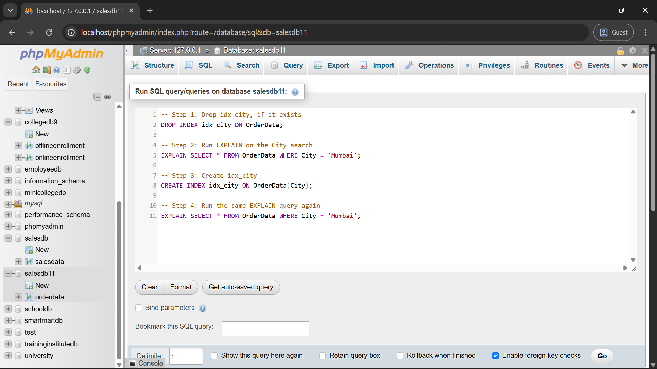
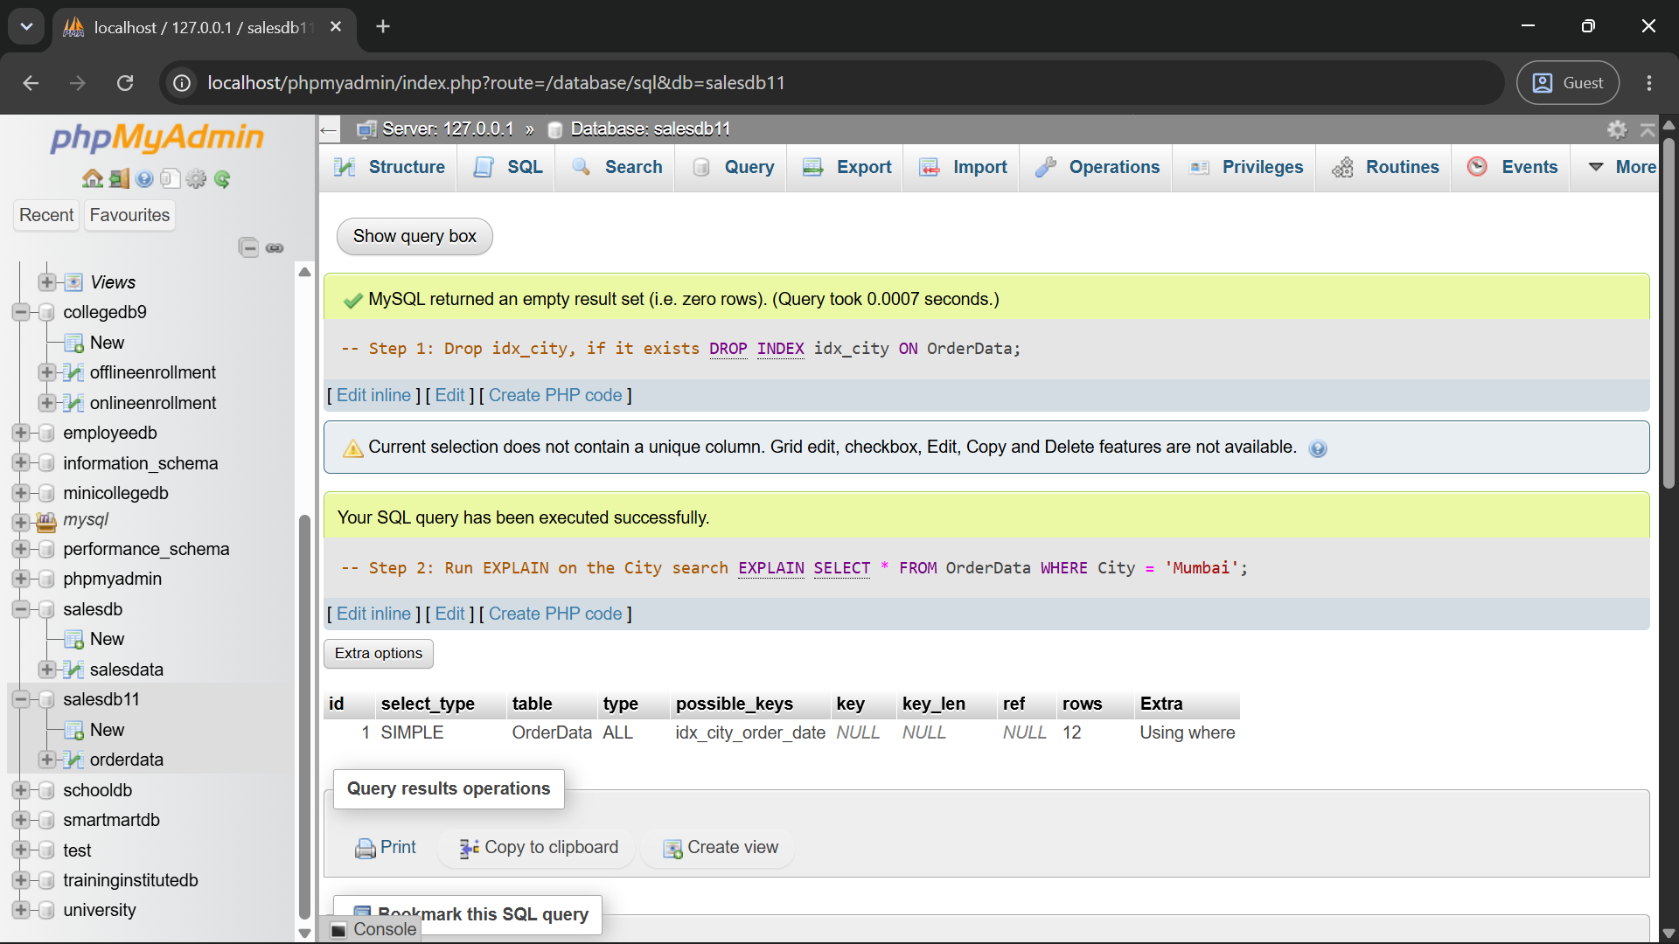
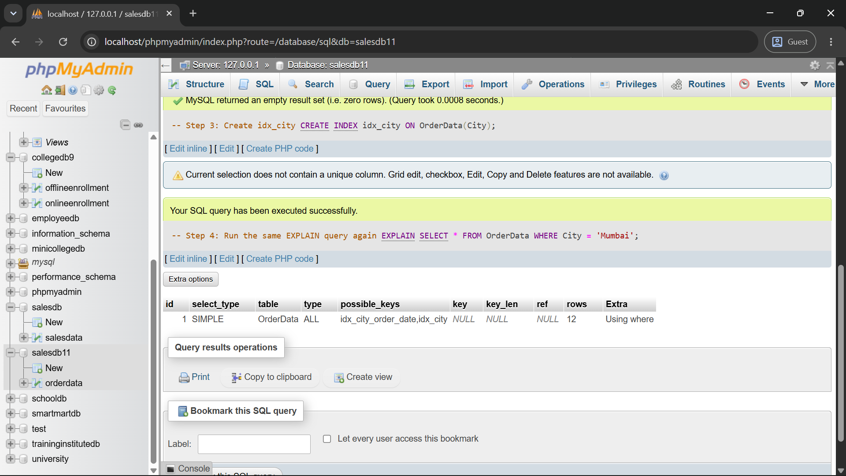
Q6) Rewrite the following query in a more index-friendly form: SELECT *
FROM OrderData
WHERE YEAR(OrderDate) = 2026;

The improved query should:

Requirement
Avoid applying a function to OrderDate
Use a start date
Use an end date
Select only OrderID, CustomerName, OrderDate, and OrderAmount
Be analyzed using EXPLAIN
Query:
EXPLAIN SELECT OrderID, CustomerName, OrderDate, OrderAmount
FROM OrderData
WHERE OrderDate >= '2026-01-01' AND OrderDate < '2027-01-01';
